ASSIGNMENT TWO: DUE DECEMBER 2ND
INSTRUCTIONS:
1. READ THE TEXT ON THE BELOW AND THINK ABOUT HOW IT MIGHT RELATE TO YOUR ART AND THE ART OF OTHERS IN YOUR CLASS.
2. WATCH VIDEO, AND GET INSPIRED.
3. COMPLETE TWO PAGES IN YOUR SKETCHBOOK USING ANY MEDIUM; CRAYON, PAINT, COLLAGE, ETC.
4. WRITE ABOUT YOUR ARTWORK AT THE BOTTOM OF THE TWO PAGES AND OR ON THE SIDES OF YOUR ART.

Observe What inspiration helps pass the ‘who cares’ test?

“So What?” i.e. What is the point you are trying to make? What is important to you? What is the outcome of completing the mission?

“Who Cares?” – i.e. Why is this relevant to the person you are talking to? How does it relate to their work or their own personal goals? Who in the class understands the problem that you are trying to resolve? Why should they care?
Get inspired see video reference & click link to view
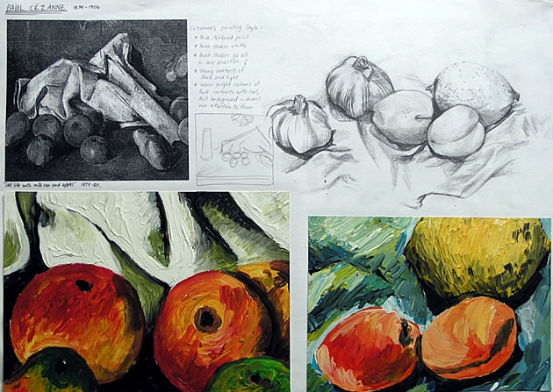
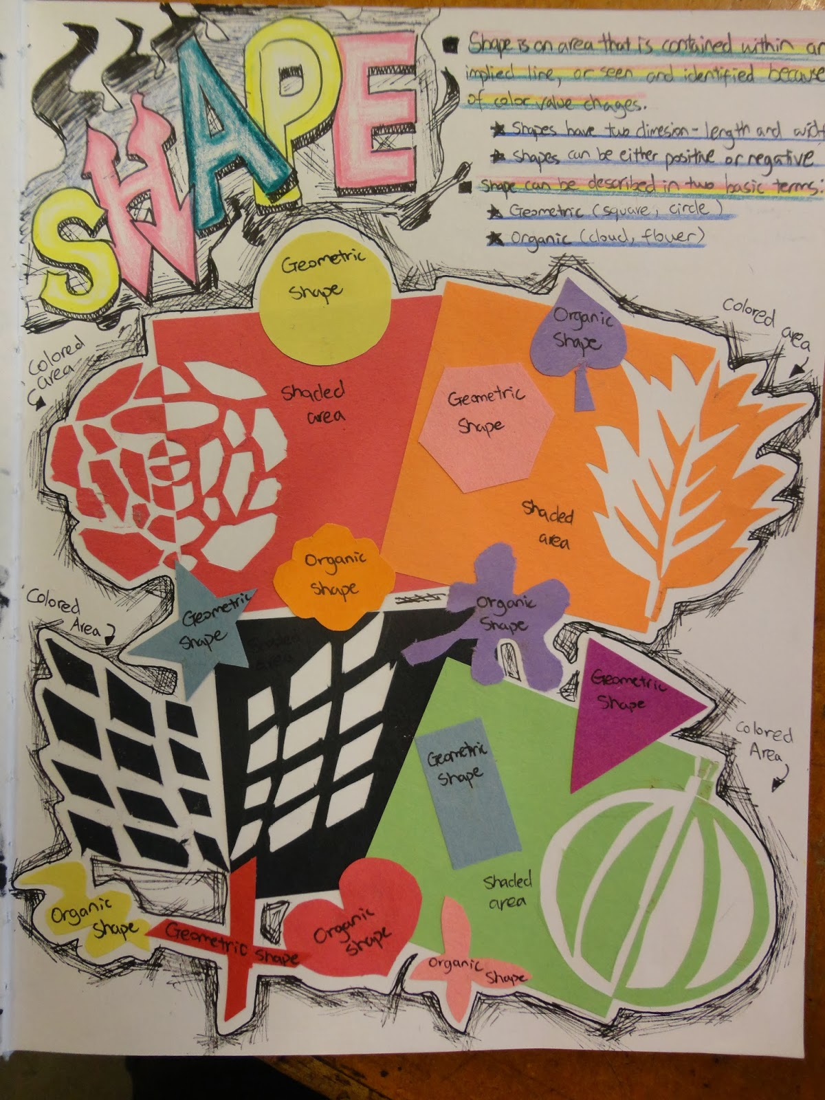
http://www.youtube.com/watch?v=H_6vOt9TxSI

