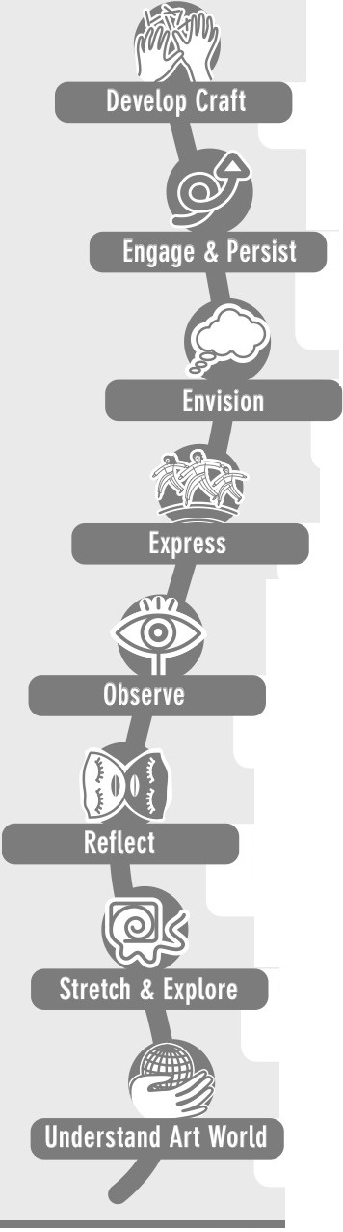Artist Habits of Mind
learning to use tools and materials. learning the practices of an art form.

learning to take up subjects of personal interest and importance within the art world. learning to develop focus and other ways of thinking helpful to working and persevering at art tasks.

learning to picture mentally what cannot be directly observed, heard or written and to imagine possible next steps in making a piece.

learning to create works that convey an idea, feeling or personal meaning.

learning to attend to visual, audible and written contexts more closely than ordinary "looking" requires; learning to notice things that otherwise might not be noticed.

learning to think and talk with others about one's work and the process of making it. learning to judge one's own and others'work and processes in relation to the standards of the field.

learning to reach beyond one's supposed limitations, to explore playfully without a preconceived plan and to embrace the opportunity to learn from mistakes and accidents.

learning about the history and practice of the art form. Interacting with other artists and the broader arts community.

